1. **AKS, GKE, EKS**
2. **Azure Devops**
3. **Azure Developer**
4. **Terraform**
5. **YAML**
6. **Docker.**
7. **AKS, GKE, EKS**
8. **Azure Devops**

Azure Devops Interview questions

1. Tell me about Microsoft hosted agent and self-hosted agent.

Ans: **Microsoft-hosted agents**

If your pipelines are in Azure Pipelines, then you've got a convenient option to run your jobs using a **Microsoft-hosted agent**. With Microsoft-hosted agents, maintenance and upgrades are taken care of for you. Each time you run a pipeline, you get a fresh virtual machine for each job in the pipeline. The virtual machine is discarded after one job (which means any change that a job makes to the virtual machine file system, such as checking out code, will be unavailable to the next job). Microsoft-hosted agents can run jobs [directly on the VM](https://learn.microsoft.com/en-us/azure/devops/pipelines/process/phases?view=azure-devops) or [in a container](https://learn.microsoft.com/en-us/azure/devops/pipelines/process/container-phases?view=azure-devops).

Azure Pipelines provides a predefined agent pool named **Azure Pipelines** with Microsoft-hosted agents.

**Self-hosted agents**

An agent that you set up and manage on your own to run jobs is a **self-hosted agent**. You can use self-hosted agents in Azure Pipelines or Azure DevOps Server, formerly named Team Foundation Server (TFS). Self-hosted agents give you more control to install dependent software needed for your builds and deployments. Also, machine-level caches and configuration persist from run to run, which can boost speed.

2.Write code to connect my sql database?

trigger:

- main

pool:

vmImage: ubuntu-latest

steps:

- task: AzureMysqlDeployment@1

inputs:

azureSubscription: '<your-subscription>

ServerName: '<db>.mysql.database.azure.com'

SqlUsername: '<username>@<db>'

SqlPassword: '$(SQLpass)'

TaskNameSelector: 'InlineSqlTask'

1. **Azure developer:**

Web app

App service

Function

Logic apps

APIM

1. **Terraform**

1. **YAML**

1. **Docker**

21-03-2023:

AKS:

<https://www.guru99.com/kubernetes-interview-questions-answers.html>

**list of objects of Kubernetes?**

1) Pods,

2) Replication sets and controllers,

3) Jobs and cron jobs,

4) Daemon sets,

5) Distinctive identities,

6) Deployments,

7) and Stateful sets

<https://github.com/prometheus-operator/kube-prometheus>

<https://www.knowledgehut.com/interview-questions/kubernetes>

Azure Key Vault is one of several [key management solutions in Azure](https://learn.microsoft.com/en-us/azure/security/fundamentals/key-management), and helps solve the following problems:

* **Secrets Management** - Azure Key Vault can be used to Securely store and tightly control access to tokens, passwords, certificates, API keys, and other secrets
* **Key Management** - Azure Key Vault can be used as a Key Management solution. Azure Key Vault makes it easy to create and control the encryption keys used to encrypt your data.
* **Certificate Management** - Azure Key Vault lets you easily provision, manage, and deploy public and private Transport Layer Security/Secure Sockets Layer (TLS/SSL) certificates for use with Azure and your internal connected resources.

How to connect VM:

1. SSH
2. RDP
3. Bastion

Authentication Type:

1.Password from Azure Key vault

2.SSH private key from local File

3.SSH private key from Azure key vault

Key vault name: A string of 3 to 24 characters that can contain only numbers (0-9), letters (a-z, A-Z), and hyphens (-)

az keyvault create --name "<your-unique-keyvault-name>" --resource-group "myResourceGroup" --location "EastUS"

Terraform Questions and answers:

<https://developer.hashicorp.com/terraform/tutorials/kubernetes/aks>

Kubernates commands:

<https://phoenixnap.com/kb/kubectl-commands-cheat-sheet>

Networking Kubernetes

<https://snyk.io/blog/kubernetes-network-policy-best-practices/>

* **Cryptographic keys**: Supports multiple key types and algorithms, and enables the use of software-protected and HSM-protected keys. For more information, see [About keys](https://learn.microsoft.com/en-us/azure/key-vault/keys/about-keys).
* **Secrets**: Provides secure storage of secrets, such as passwords and database connection strings. For more information, see [About secrets](https://learn.microsoft.com/en-us/azure/key-vault/secrets/about-secrets).
* **Certificates**: Supports certificates, which are built on top of keys and secrets and add an automated renewal feature. Keep in mind when a certificate is created, an addressable key and secret are also created with the same name. For more information, see [About certificates](https://learn.microsoft.com/en-us/azure/key-vault/certificates/about-certificates).
* **Azure Storage account keys**: Can manage keys of an Azure Storage account for you. Internally, Key Vault can list (sync) keys with an Azure Storage Account, and regenerate (rotate) the keys periodically. For more information,

Primary Skill: Azure, Azure DevOps, AKS.

Secondary skill: Power Shell, Docker, Prometheus, Grafana, Rally, Jira, SonarQube.

Grade & Location: C1 & Hyderabad.

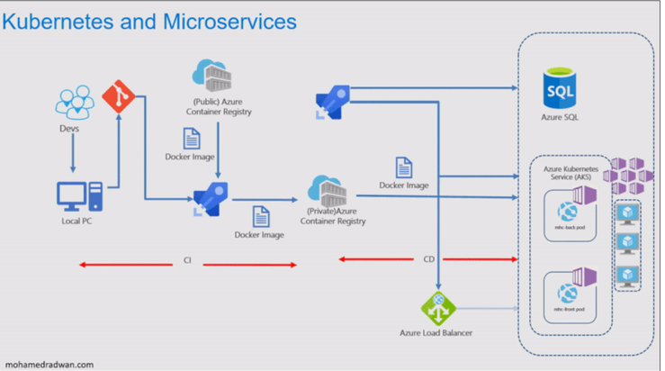

m<https://www.azuredevopslabs.com/labs/vstsextend/kubernetes/>

Build Pipeline--CI

Release pipeline—CD

YAML Pipeline –---- CI+CD

Yaml pipeline support

Azure repos yaml

Configure- ASP Not Net template

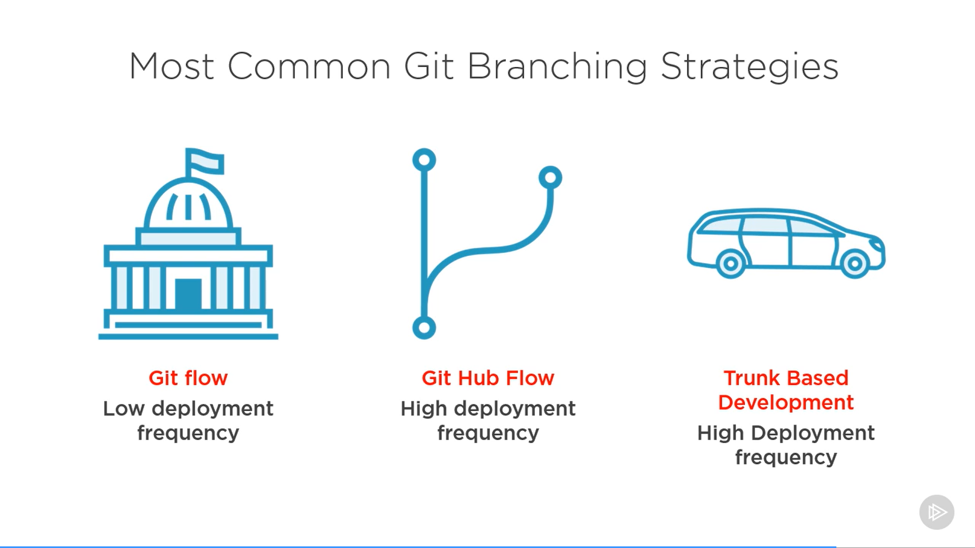

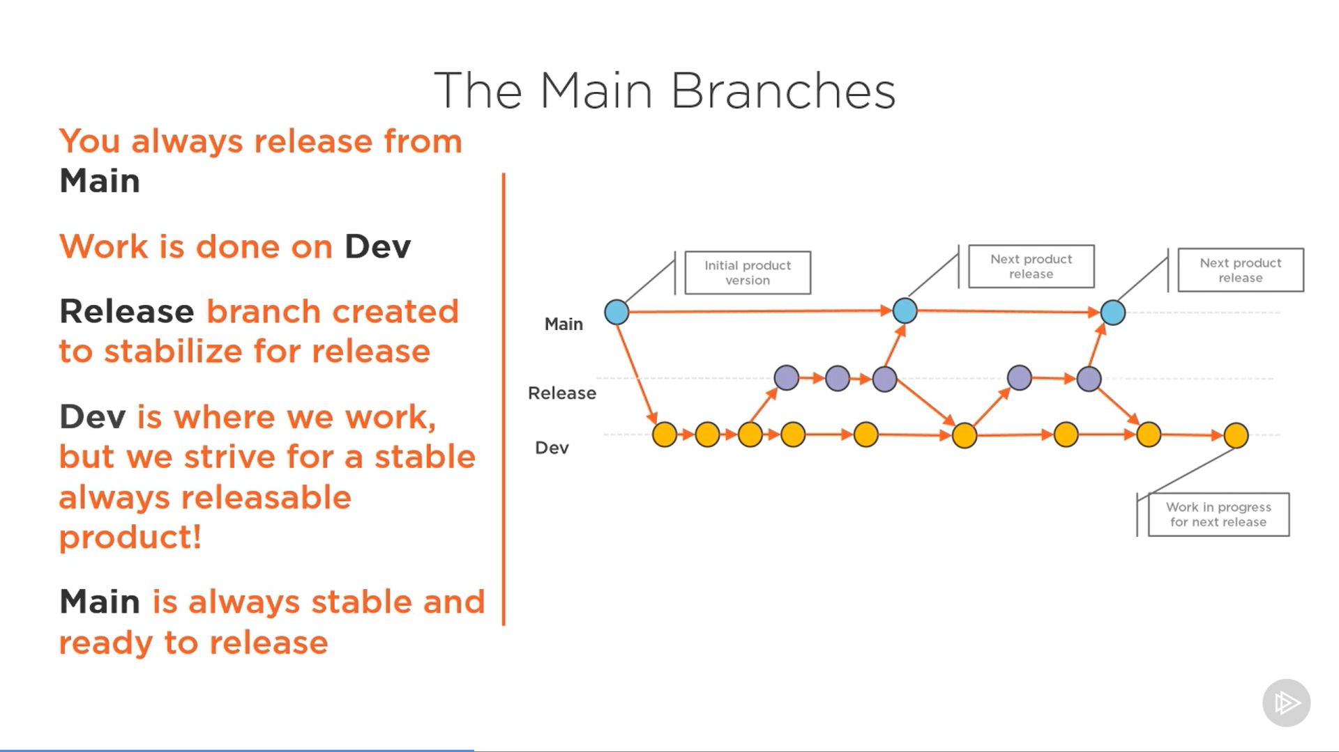

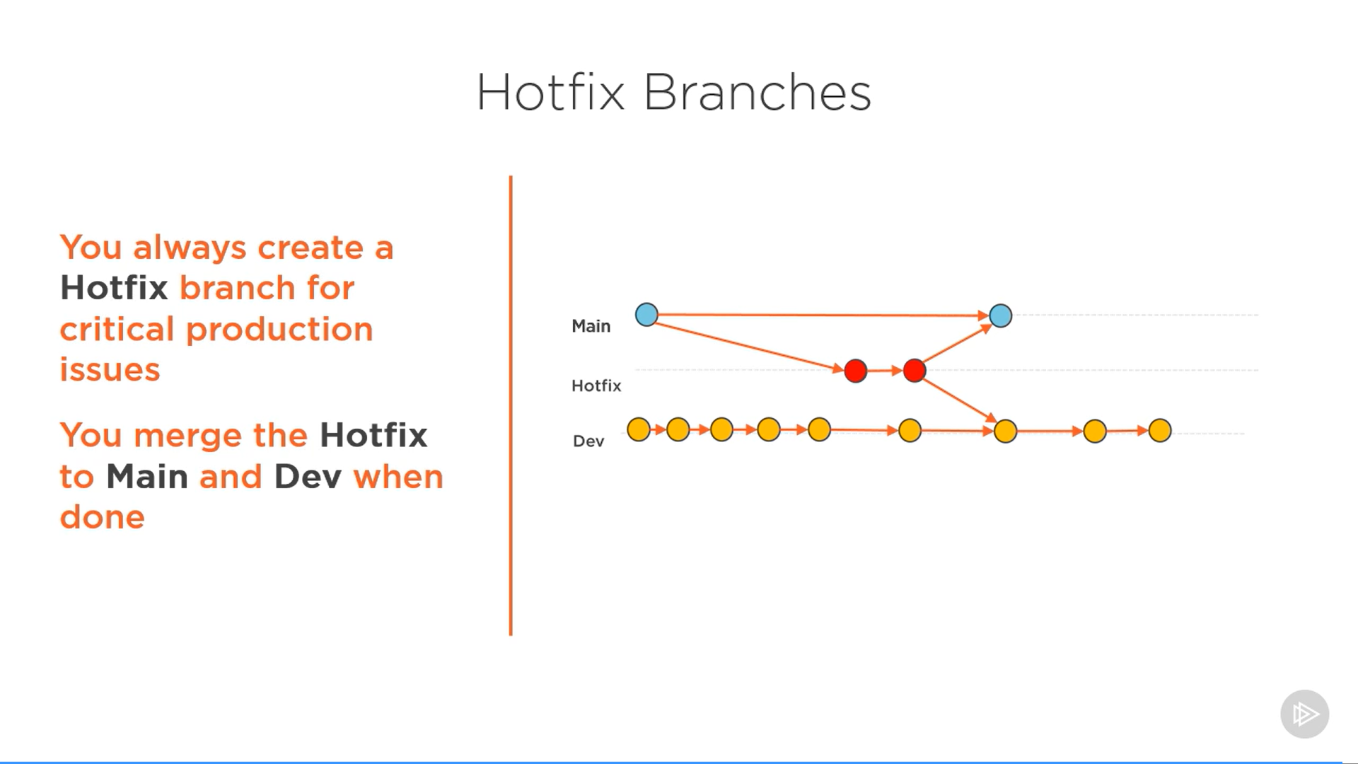

SIRISHA

0122341648

##### **0122344404**

New one---0122344404

0122344404